****

**SCHOOL OF ELECTRONICS AND COMMUNICATION ENGINEERING**

COURSE BASED PROJECT - MICROCONTROLLER AND ARM PROCESSOR APPLICATIONS

ON

“**SERIAL COMMUNICATION USING LORA RF96”**

Submitted in fulfillment of the requirements for the award of the Degree of

**BACHELOR OF TECHNOLOGY**

**IN**

**Electronics and Communication Engineering/**

Submitted by

**R22EN130 – Niranjan Meti**

**R22EN155 – Shashank Reddy V**

**R22EN157 – Shreya R**

**R22EN166 – A Sahithya**

Under the guidance of

Prof. Anil kumar.CS,

Assistant Professor

School of ECE, REVA University

June 2024

Rukmini Knowledge Park, Kattigenahalli, Yelahanka, Bengaluru-560064

www.reva.edu.in

**DECLARATION**

We (R22EN130)Niranjan Meti,(R22EN155)Shashank Reddy V,(R22EN157)Shreya R ,(R22EN166)A Sahithya students of B. Tech inElectronics and Communication Engineering belonging to the School of Electronics and Communication Engineering, REVA University, declare that this Skill Development Course Report entitled **“SERIAL COMMUNICATION USING LORA RF96”** is the case study of Skill Development Course work done by me under the supervision of Prof. Jyothy S T, Assistant Professor, School of ECE REVA University.

I am submitting this Course Based Project - Microcontroller and ARM Processor Applications report in partial fulfillment of the requirements for the award of degree of Bachelor of Technology in Electronics and Communication Engineeringby the REVA University, Bengaluru during the academic year 2024-25.

I declare that this case study report satisfies the academic requirements concerning the mini-project work prescribed for the said Degree. I further declare that this Skill Development Course report or any part of it has not been submitted for the award of any other Degree/Diploma of this University or any other University/ Institution.

*Signature of the Students*

*Date*

*Certified that this Course Based Project - Microcontroller and ARM Processor Applications project work submitted by* (R22EN130) Niranjan Meti,(R22EN155) Shashank Reddy V,(R22EN157) Shreya R ,(R22EN166) A Sahithya ***﻿*** *has been carried out under my / our guidance and the declaration made by the candidate is true to the best of my knowledge.*

*Signature of Guide*

*Date:*



# CERTIFICATE

Certified that the Course Based Project - Microcontroller and ARM Processor Applications project work entitled “**SERIAL COMMUNICATION USING LORA RF96**” carried out under my guidance by(R22EN130)Niranjan Meti,(R22EN155)Shashank Reddy V,(R22EN157)Shreya R,(R22EN166)A Sahithyaa bonafide student of REVA University during the academic year 2024-25, is submitting the Course Based Project - Microcontroller and ARM Processor Applications project report in partial fulfillment for the award of **Bachelor of Technology i**n **Electronics and Communication Engineering** during the academic year **2024-25.** The project report has been approved as it satisfies the academic requirements in respect of the Project work prescribed for the said Degree.

|  |  |  |
| --- | --- | --- |
| **Signature with Date** | **Signature with Date** | **Signature with Date** |
|  |  |  |
| **Prof. Anil kumar.CS**, |  |  |
| **Guide** | **HOD (ECE)** | **Director, School of ECE** |

|  |  |  |  |
| --- | --- | --- | --- |
|  | **Name of the Examiner with** **affiliation** |  | **Signature with Date** |
| 1. |  |  |  |
| 2. |  |  |  |

# INTRODUCTION

**LORA**(short for **Long Range**) is a wireless communication technology designed for low-power, long-range transmissions. It is widely used in Internet of Things (IOT) applications to enable devices to communicate over long distances without consuming too much energy. LORA operates on sub-GHz frequencies and is part of the **LORA WAN** protocol, which is specifically designed to manage the network architecture, data transmission, and security for LORA based systems.In an increasingly interconnected world, long-range communication technologies play a vital role in applications such as environmental monitoring, smart cities, and industrial automation.**LORA**  a modulation technique for long-range, low-power wireless communication, is particularly advantageous due to its capacity to transmit data over several kilo metres with minimal power consumption. This project utilizes **LORA**  RF96 modules connected to Arduino Uno boards to create a basic communication setup. It highlights the feasibility of LoRa in developing cost-effective and reliable communication systems, showcasing its potential for various real-world applications.

Unlike conventional wireless communication technologies such as Wi-Fi or Bluetooth, which are constrained by limited range and high-power requirements, LoRa operates on unlicensed frequency bands and uses spread spectrum modulation to achieve enhanced range and reliability. Its ability to transmit data even in environments with physical obstructions makes it ideal for applications in rural and urban areas. By implementing a LoRa- based communication system, this project demonstrates how this technology can be utilized for various purposes, including agriculture, environmental monitoring, and industrial IOT, fostering innovation in remote sensing and long-distance communication. LORA technology is ideal for use cases where there is a need for wireless communication over long distances with low power consumption, such as in rural areas or locations where traditional wireless technologies like Wi-Fi or cellular networks are not practical.

# LITERATURE SURVEY

An alternative communication system is essential for areas without telecommunication services or during disasters. Technologies like LoRa WAN, with low energy consumption and long-range coverage, are suitable for such scenarios. The proposed instant messaging system uses two TTGO LoRa 32 devices, one for transmission (TX) and the other for reception (RX), configured on separate channels to avoid interference. Energy consumption was evaluated by sending messages every 5 seconds, averaging 0.048A with a median of 0.04A. Transmission mode consumes more energy. Tests conducted on the ground successfully sent and received messages. This system is invaluable in disasters, enabling users to send help or warning messages. It is also useful in remote rural areas and for communication between vessels in oceans and large lakes [1].

With the advancement of China's agricultural reforms, the demand for Chinese herbal medicines is growing, with artificial cultivation becoming a trend. However, challenges persist, including natural disasters, unsuitable planting environments, and growers' limited experience in managing conditions like drought, waterlogging, and frost. To address these issues, this paper proposes an IoT-based environmental control system for herbal medicine cultivation. The system ensures optimal growing conditions for various herbs and their growth stages by using sensors, LoRa communication, and actuators. It monitors and regulates temperature, humidity, soil moisture, and light intensity in greenhouses in real time. Growers can remotely manage these parameters, defending against natural disasters and achieving automation, intelligence, and digitization in herbal medicine farming [2].

To address short communication range and high power consumption in manhole cover monitoring, LoRa technology is introduced for its long-range, low-power capabilities. The application architecture of LoRa in an intelligent manhole cover monitoring system is analyzed and tested. Results show LoRa achieves a communication range of 700 meters and battery life exceeding 3 years. This ensures low power consumption and long-range performance, providing an effective solution for urban manhole cover safety management. The system offers a new approach to interconnecting IoT devices under similar conditions, advancing the development of smart city infrastructure [3].

This paper explores the use of Long Range (LoRa) technology for requesting pressure and temperature (P&T) sensor data and retrieving measurements over the 2.4 GHz ISM band. Using LoRa development kits (SX1280), a network comprising one Master board and multiple Sensor boards (slaves) was implemented, with each slave interfacing with P&T sensors. The quality and performance of the LoRa network were evaluated under varying parameter settings. Despite significant electromagnetic activity in the 2.4 GHz band, data transmission tests were successful. The study analyzed the communication range across different scenarios, focusing on the impact of the spreading factor (SF) parameter on network performance [4].

LPWA (Low Power Wide Area) is expected to be a communication technology suitable for the Internet of Things (loT) because of its features. Since LoRa communication has a trade-off between communication range and transmission rate, performance is inherently varied depending on the surrounding environment. Therefore, to achieve stable and efficient communication performance, it is necessary to set appropriate parameters for LoRa depending on the communication environment between the base station and the terminal. We here propose a method for dynamic control of parameter settings based on reception statistics of beacons. The effectiveness of the proposed method is evaluated from the real experiments [5].

Due to its particular features, LoRa is gaining more and more attention from industry and academia because it tries to combine long communication range, low-power consumption, and low-data rate application. A very important feature observed on LoRa is that it is highly robust and reliable. Due to this, LoRa is being applied in many IoT solutions in urban environment, but on hard natural environments like dense forest, near river sides, lakes and mangroves, more studies need to be carried out in order to evaluate the its quality. This paper describes experimental studies carried out to measure LoRa communication range and Received Signal Strength Indicator (RSSI), both in natural and urban environments. The experiments took place in two different places of the world, one in the northern hemisphere and another in the southern hemisphere: on the Portuguese archipelago of the Azores (in SãoMiguel Island) and in the city of João Pessoa in Northeast of Brazil, respectively. As a result, we observed that LoRa is very robust in dense urban environments, where it was possible to established long distance connections (approximately 2.1 km). However, the results were inconclusive in forest environments, because in the Azores, the LoRa connection ranged about 800 m thought the forest/lake, while in Brazil it was about 230 m [6].

This paper proposes an effective method of IoT solution using nanosatellite communication for remote monitoring of electrical substations. The method deploys a smart IoT LoRa terminal called a node. It records the collected data from sensors and transmits it using LoRa (Long Range) adaptive data packets to the LEO (Low Earth Orbit) satellite at specific time intervals depending on the satellite time of visibility and access duration. The implementation of the LoRa Technology in this application allows peer to peer communication between the nodes and the nanosatellite. However, there are some limitations with LoRa and LEO satellite communication. The solution to these limitations has been demonstrated using modelling and simulation methodology. The proposed method improves the IoT-based nanosatellite remote monitoring of electrical sub-stations by mitigating the impact of the limitations. Furthermore, the study shows the nanosatellite view in 2D, 3D, and the target substation's access time by varying its altitude, azimuth, and elevation angles [7].

We conduct communication environment measurement in Chikuma city, Nagano prefecture, Japan, utilizing community bus services via private Long Range (LoRa), which is one of the low-power wide area (LPWA) communication technologies. Chikuma city has approximately 119.8 km^2 area and a population of 59,380, which is a medium-sized rural city in Japan. In this experiment, we set up LoRa relay stations at three locations in the city: the Koshoku city hall building (at the northern part of the city), the Togura municipal building (at the southern part of the city), and the Amenomiya drainage station (at the eastern part of the city). In addition, beacon transmitters are installed in the community buses (nine routes in all). The location and time information are transferred from the routes of the buses to a cloud system in real time through the relay stations. Experimental results are summarized in an area map, indicating that we succeed in communicating in 61.3% of data points on the bus routes and confirm the possibility of covering the entire city by the LPWA. We are able to expand the LoRa communication area by adding more relay stations paying attention to terrain effects [8].

Accidents in aquatic environments pose significant risks, requiring innovative solutions for timely intervention. This paper proposes integrating LoRa technology into wearable life jackets with IoT capabilities to enhance safety and streamline rescue operations. Smart life jackets with sensors and wireless connectivity enable real-time tracking of individuals in distress. In emergencies, rescue signals are autonomously transmitted to stations and lifeguards, ensuring quick intervention. LoRa technology extends communication range and reliability, essential for diverse aquatic environments. IoT integration enables comprehensive data management and analysis, facilitating proactive water safety measures. This initiative aims to improve safety standards and the quality of aquatic experiences, offering a safer environment for water enthusiasts [9].

This paper describes a new method for maximizing the wireless sensing network’s throughput communicating with Long Range (LoRa) modulation at a 2.4 GHz frequency. We propose a wireless sensing Network topology that depends on the spreading factor (SF) in the case of dense traffic between a LoRa master board and several LoRa sensor nodes. The receiver uses the channel activity detection (listening) mode to find a suitable SF during the preamble period by switching its SF. Our dynamic SF adjustment algorithm aims to maximize and optimize the throughput of sensor data without needlessly exchanging packets between the LoRa master board and the LoRa sensor nodes. Different ranges of performance with our proposed algorithm are studied, for several scenarios depending on the spreading factors parameter [10].

# PROBLEM STATEMENT

Traditional wireless communication systems often face challenges such as limited range, high power consumption, and interference in urban or remote environments. Existing solutions, such as Wi-Fi or Bluetooth, either lack the necessary range or are unsuitable for applications requiring low-power operation over vast areas. The absence of a reliable, energy-efficient long-range communication framework hinders the progress of IoT-based systems and remote data monitoring. This project addresses this gap by implementing a LoRa-based communication system, providing an effective alternative for low-power, long-distance data transmission.

# OBJECTIVES

1. **Design and Implementation:** To design and implement a LoRa-based communication system using LoRa RF96 modules interfaced with Arduino Uno, ensuring accurate and reliable data transmission between a transmitter and receiver.
2. **Evaluate LoRa Technology:** To explore and evaluate the capabilities of LoRa technology, such as its long-range communication, low power consumption, and ability to function in challenging environments with physical obstructions.
3. **Establish a Wireless Data Link:** To establish a stable and efficient wireless communication link for transmitting and receiving data over significant distances without relying on existing communication infrastructure.

# METHODOLOGY:

# Component Selection and Preparation

# Select essential components for the project, including LoRa RF96 modules, Arduino Uno boards, jumper wires, and breadboards.

# Ensure compatibility between the LoRa module and Arduino by reviewing voltage requirements and pin configurations.

# Hardware Setup

# Connect the LoRa RF96 module to the Arduino Uno as per the specified pin configuration:

# VCC → 3.3V

# GND → GND

# SCK → D13

# MOSI → D11

# MISO → D12

# NSS (CS) → D10

# RST → D9

# DIO0 → D2

# Assemble the transmitter and receiver circuits with identical hardware configurations.

# Software Development

# Install the necessary Arduino libraries for LoRa communication, such as the "LoRa.h" library.

# Write and upload separate Arduino codes for the transmitter and receiver. The transmitter code sends data packets, while the receiver code decodes and displays received data.

# Implement error-checking mechanisms to ensure reliable data transmission.

# Communication Testing

# Test the setup in a controlled environment to confirm successful data exchange between the transmitter and receiver.

# Debug and resolve hardware or software issues such as wiring errors, signal interference, or incorrect configurations.

# Range and Reliability Evaluation

# Measure the communication range of the LoRa modules by placing the transmitter and receiver at increasing distances.

# Test the system in different environments, such as indoors and outdoors, to evaluate performance in terms of range, signal strength, and reliability.

# Energy Consumption Analysis

# Monitor the power consumption of the system to ensure low-power operation suitable for remote or battery-powered applications.

# Real-World Application Simulation

# Simulate a real-world application, such as sending temperature, humidity, or other sensor data from the transmitter to the receiver.

# Display the received data on a serial monitor or an external display for analysis.

# Documentation and Presentation

# Document the entire process, including the circuit diagrams, code, test results, and observations.

# Present the findings and demonstrate the working prototype to showcase the practical utility of the LoRa-based communication system.

# Transmitter and Receiver Methodology

# Configure the RF96 module for transmission (frequency, bandwidth, and power.Establish SPI communication between the Arduino and RF96.Send the data wirelessly in packets at fixed intervals.Initialize the RF96 module to continuously listen for incoming packets.When data is received, demodulate it and forward it to the Arduino.

# 6. BLOCK DIAGRAM

# WhatsApp Image 2024-12-17 at 09.41.14_99f989a1

**Fig 1: Block diagram of Transmitter.**

The transmitter's job is to **collect data**, process it, and send it wirelessly to the receiver using the LoRa module. The components are:

* **Input**:  
  Represents the source of the data or information to be transmitted (e.g., sensor values, user input).
* **Arduino Nano**:  
  A microcontroller that processes the input data and prepares it for transmission. It acts as the controller for the transmitter system.
* **Battery**:  
  Supplies power to the Arduino Nano and other components.
* **LoRa Module**:  
  The communication module responsible for transmitting the processed data wirelessly to the receiver side.
* **Antenna**:  
  Connected to the LoRa module, it helps broadcast the signal to a long range.
* **Receiver (on transmitter side)**:  
  Indicates the system interface where the signal is sent for communication.

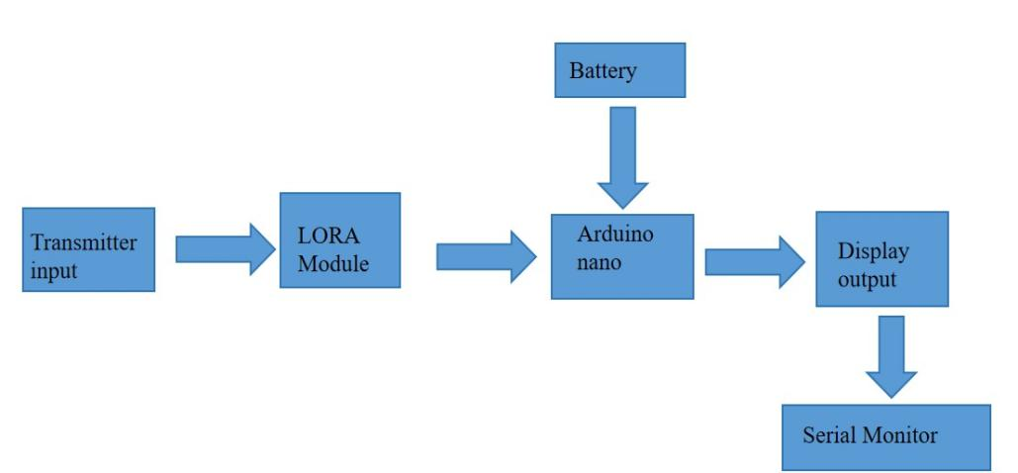

**Fig 2: Block diagram of Receiver**

The receiver section **receives the transmitted data**, processes it, and displays it for the user. The components are:

* **Transmitter Input**:  
  Represents the signal sent by the transmitter through the LoRa module.
* **LoRa Module**:  
  This module receives the transmitted signal wirelessly.
* **Arduino Nano**:  
  Processes the received data from the LoRa module. It acts as the brain of the receiver system.
* **Battery**:  
  Powers the Arduino Nano and the connected components.
* **Display Output**:  
  The processed data is displayed, such as on an LCD screen or any output display device.
* **Serial Monitor**:  
  Optionally, the data can also be displayed on a serial monitor connected to a computer for debugging or monitoring purposes.

**7.COMPONENTS**

|  |  |  |  |
| --- | --- | --- | --- |
| **SL.NO** | **Components** | **Range** | **Quantity** |
| 1 | Arduino Uno |  | 2 |
| 2 | Lora rf96 | 15-20kms | 2 |
| 3 | Jumper wires | - | - |

The **LoRa RF96** is a low-power, long-range wireless module using LoRa technology. It supports distances up to several kilometers with low data rates (0.3 kbps to 37.5 kbps). It operates on frequency bands like 433 MHz, 868 MHz, and 915 MHz. Ideal for IoT applications like smart agriculture and remote sensors.

The **Arduino Uno** is a popular microcontroller board based on the ATmega328P chip. It features 14 digital I/O pins, 6 analog inputs, and is programmed via the Arduino IDE. It supports a wide range of sensors and modules for various projects. Ideal for beginners and prototyping in electronics and robotics.

**8. CIRCUIT DIAGRAM**

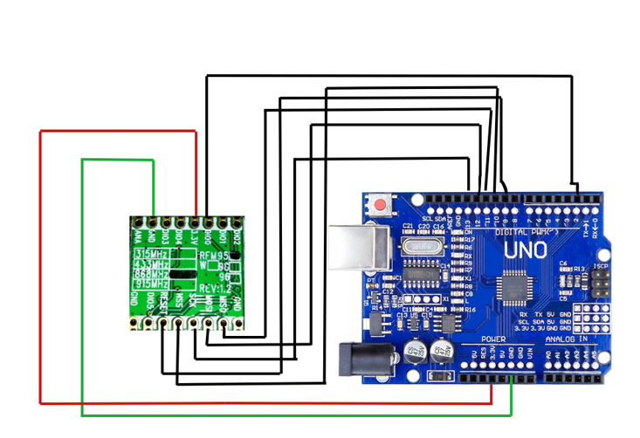

## Fig 2: Circuit Diagram of serial communication using LORA

# Working of RF96 LoRa with Arduino Uno

# The RF96 LoRa module enables wireless communication using LoRa modulation technology, which provides long-range, low-power data transmission. The module communicates with the Arduino Uno via SPI protocol.

# 1. Transmitter Working

# The transmitter Arduino sends data to the RF96 module using SPI communication.The RF96 module modulates the data into a LoRa signal at 433 MHz and transmits it wirelessly to the receiver.

# 2. Receiver Working

# The receiver Arduino is connected to another RF96 module, which continuously listens for incoming signals.When the RF96 module receives data, it demodulates the LoRa signal and transmits the data to the Arduino via SPI.

The circuit diagram shows an Arduino Uno microcontroller connected to an RFM95 LoRa (Long Range) radio module, which is used for wireless communication. The red wire connects the VCC pin of the RFM95 module to the 3.3V power supply pin of the Arduino, providing power to the module. The green wire connects the GND (ground) pin of the RFM95 to the Arduino's ground, ensuring a common reference point for the circuit.

Several black wires represent data and control signal connections between the Arduino and the RFM95 module, likely using the SPI (Serial Peripheral Interface) communication protocol. These connections include:

* **MOSI (Master Out Slave In)**: Transmits data from the Arduino to the module.
* **MISO (Master In Slave Out)**: Sends data from the module to the Arduino.
* **SCK (Serial Clock)**: Synchronizes data transfer.
* **CS (Chip Select)**: Activates the module for communication.
* Additional connections may link the module's DIO pins to Arduino's digital pins for handling interrupts or additional features.

This configuration enables the Arduino to control the RFM95 module for transmitting and receiving data over long distances using the LoRa protocol. Proper code and libraries, such as LoRa or RadioHead, are required to manage the communication between the Arduino and the module effectively.

# RESULT AND DISCUSSION

**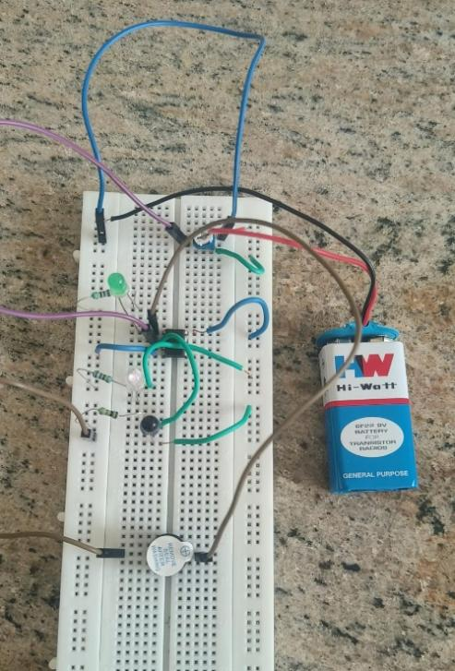**

# CONCLUSION

#### LoRa technology has revolutionized communication in low-power, long-range, and low-bandwidth scenarios. Its ability to send and receive small data packets efficiently makes it indispensable for a wide range of applications, from IoT networks and industrial automation to rural connectivity and emergency response systems. With its inherent advantages such as scalability, affordability, and adaptability to remote and challenging environments. LoRa bridges communication gaps where traditional methods fall short. As innovations in satellite integration, security protocols, and hybrid networks continue, LoRa's role in enabling smart and sustainable solutions will only grow stronger.

#### **Overall Impact:**

The overall impact of using LoRa for sending and receiving messages is profound, transforming communication systems across various domains. LoRa's ability to provide long-range, low-power, and cost-effective connectivity has made it a cornerstone of IoT applications, fostering innovation in industries such as agriculture, healthcare, smart cities, and industrial automation. Its resilience in remote and underserved regions bridges the digital divide, enabling rural connectivity and supporting critical applications like disaster management and environmental monitoring. LoRa promotes sustainability and economic growth. LoRa's unique capabilities are not just enhancing existing communication infrastructures but are also paving the way for new possibilities in connectivity, fostering a smarter, more inclusive, and sustainable world.

#### **Future Scope:**

#### **1. Enhanced IoT Communications**

#### **Smart Cities:** Real-time alerts for traffic, public safety, or utility monitoring can be achieved through LoRa-based communication.

#### **Asset Tracking:** Sending and receiving location updates for vehicles, goods, or people in logistics and supply chains.

#### **Home Automation:** Enabling devices like alarms, sensors, and lighting to exchange status messages.

**2. Emergency Communication Systems**

* **Natural Disasters**: During floods, earthquakes, or wildfires, LoRa can facilitate communication for search and rescue operations.
* **Remote Medical Support**: Sending health alerts or SOS signals from patients in underserved areas to emergency services.

**3. Long-Range Communication in Remote Areas**

* **Rural Connectivity**: Farmers or workers in remote locations can send/receive vital information, such as weather alerts or equipment status.
* **Exploration Missions**: Sending telemetry data or alerts in inaccessible areas like mountains, deserts, or forests.

# 

# REFERENCES

1. J. E. Cruz De La Cruz, C. A. Romero Goyzueta, E. V. Sagua Machaca and W. A. Mamani Machaca, "LoRaWAn Instant Messaging System For Areas Without Telecommunication Services and Disaster Environment," 2021 International Conference on Electrical, Computer, Communications and Mechatronics Engineering (ICECCME), Mauritius, Mauritius, 2021, pp. 1-4, doi: 10.1109/ICECCME52200.2021.9591033. keywords: {Earth;Wide area networks;Sea surface;Energy consumption;Mechatronics;Instant messaging;Interference;lorawan;lpwan;instant messaging;ttgo lora;alternative telecommunication service},
2. W. Xue and X. Zhang, "Herbal environmental control system based on LoRa communication," 2024 4th International Symposium on Computer Technology and Information Science (ISCTIS), Xi’an, China, 2024, pp. 202-206, doi: 10.1109/ISCTIS63324.2024.10699104. keywords: {Temperature sensors;Wireless communication;Temperature distribution;Disasters;Soil moisture;LoRa;Humidity;Greenhouses;Control systems;Real-time systems;IOT;LoRa wireless communication;smart agriculture},
3. L. Xuan, Z. Hesheng and L. Lei, "Research on LoRa Communication Performance in Manhole Cover Monitoring," 2019 IEEE International Instrumentation and Measurement Technology Conference (I2MTC), Auckland, New Zealand, 2019, pp. 1-6, doi: 10.1109/I2MTC.2019.8826898. keywords: {Monitoring;Wireless communication;Power demand;Roads;Bandwidth;Modulation;Sensitivity;intelligent manhole cover monitoring;LoRa;low power and long distance communication;performance test evaluation},
4. R. M. Ghodhbane, A. Hernandez and S. Janfaoui, "A Pressure and Temperature Wireless Sensing Network Communicating with LoRa Modulation," 2024 IEEE Symposium on Computers and Communications (ISCC), Paris, France, 2024, pp. 1-3, doi: 10.1109/ISCC61673.2024.10733589. keywords: {Temperature sensors;Temperature measurement;Wireless communication;Wireless sensor networks;Temperature distribution;LoRa;Main-secondary;Sensors;Pressure measurement;Frequency measurement;sensor network;communication;Long Range (LoRa) modulation;and Spreading factor parameter},
5. R. Tanaka, D. Nobayashi, K. Tsukamoto, T. Ikenaga, G. Sato and K. Takizawa, "Dynamic Transmission Parameter Settings Based on Data Transmission and Reception Performance for 920MHz LoRa Communication," 2024 IEEE 21st Consumer Communications & Networking Conference (CCNC), Las Vegas, NV, USA, 2024, pp. 1102-1103, doi: 10.1109/CCNC51664.2024.10454734. keywords: {Fading channels;Base stations;Communications technology;Internet of Things;Low Power Wide Area (LPWA);Private LoRa Network;Parameter Setting},
6. M. R. Villarim et al., "An Evaluation of LoRa Communication Range in Urban and Forest Areas: A Case Study in Brazil and Portugal," 2019 IEEE 10th Annual Information Technology, Electronics and Mobile Communication Conference (IEMCON), Vancouver, BC, Canada, 2019, pp. 0827-0832, doi: 10.1109/IEMCON.2019.8936194. keywords: {Forestry;Lakes;Chirp;Urban areas;Frequency modulation;Internet of Things;Wireless communication;Wireless communication;Chirp modulation;Low-power electronics;Performance evaluation;LoRa modulation},
7. J. V. Karunamurthy, S. A. Bendoukha, I. Nikolakakos, T. Ghaoud, F. Ebisi and M. R. Alkharrat, "Adaptive Technique for LoRa Communication with LEO Nanosatellite," 2021 IEEE Microwave Theory and Techniques in Wireless Communications (MTTW), Riga, Latvia, 2021, pp. 182-187, doi: 10.1109/MTTW53539.2021.9607055. keywords: {Wireless communication;Adaptation models;Satellites;Substations;Three-dimensional displays;Software algorithms;Low earth orbit satellites;LoRa Protocol;IoT;LEO Satellite;Nanosatellite;Data frame;Remote monitoring;Electrical sub-station Monitoring;LoRa node},
8. K. T. Murata et al., "LoRa Communication Maps of Medium-Sized Rural City in Japan via Community Bus Services," 2019 IEEE Intl Conf on Dependable, Autonomic and Secure Computing, Intl Conf on Pervasive Intelligence and Computing, Intl Conf on Cloud and Big Data Computing, Intl Conf on Cyber Science and Technology Congress (DASC/PiCom/CBDCom/CyberSciTech), Fukuoka, Japan, 2019, pp. 1054-1059, doi: 10.1109/DASC/PiCom/CBDCom/CyberSciTech.2019.00189. keywords: {Urban areas;Relays;Buildings;Transmitters;Information and communication technology;Area measurement;LPWA;LoRa;communication map;Chikuma city},
9. N. S. Kumar, C. R, N. S. M, P. R and P. V. P, "Wearable IoT Life Jacket: Utilizing LoRa Technology to Combat Hypothermia," 2024 International Conference on Smart Systems for Electrical, Electronics, Communication and Computer Engineering (ICSSEECC), Coimbatore, India, 2024, pp. 23-27, doi: 10.1109/ICSSEECC61126.2024.10649536. keywords: {Wireless communication;Temperature sensors;Technological innovation;Wireless sensor networks;LoRa;Electric variables measurement;Reliability;LoRa technology;wearable life jackets;IoT capabilities;safety measures;rescue operations;real-time tracking;communication range;proactive measures;water safety},
10. R. M. Ghodhbane, "Maximization of Wireless Sensing Network’s Throughput Communicating with Long Range (LoRa) Modulation," 2024 IEEE 7th International Conference on Advanced Technologies, Signal and Image Processing (ATSIP), Sousse, Tunisia, 2024, pp. 594-599, doi: 10.1109/ATSIP62566.2024.10638955. keywords: {Wireless communication;Wireless sensor networks;Frequency modulation;Network topology;Heuristic algorithms;LoRa;Switches;Maximizing the throughput;sensor network;communication;Long Range (LoRa) modulation;Spreading factor parameter;channel activity detection},